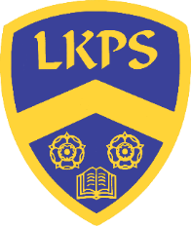
Year 2 Long Term Plan

Autumn

 |  | W1 | W2 | W3 | W4 | W5 | W6 | W7 |  | W1 | W2 | W3 | W4 | W5 |  | W6 | W7
Science | What do animals and humans need to survive?  (Animals inc humans)
Non-Core |  |  |  |  | Geography: Where in the world do I live and what are the human and physical features of the UK? |  |  | Art: Map it out (Craft & Design) |  | Art: Map it out (Craft & Design) | History: Why did the Great fire of London happen and what did we change after? |  |  |  | DT: Baby bear’s chair  (Structures) |  | NATIVITY
Computing | Catch up unit  See catch up document  OS Safety Lesson 1 |  |  |  |  |  |  |  |  | Computing systems and networks 1  What is a computer?  OS Safety Lesson 2
RE | Who is a Muslim and what do they believe?  Islam  Believing |  |  |  |  |  |  |  |  | Continued… Who is a Muslim and what do they believe?  Islam  Believing
Music | Hands, Feet, Heart |  |  |  |  |  |  |  |  | Ho Ho Ho
PE | Gymnastics – turning and twisting |  |  |  |  |  |  |  |  | Dance – The Great Fire of London
PSHE | Introductory lesson: Setting ground rules for  RSE and PSHE.  Family and relationships |  |  |  |  |  |  |  |  | Family and relationships  Health and wellbeing
Spanish | Not taught in KS1 |  |  |  |  |  |  |  |  | Not taught in KS1

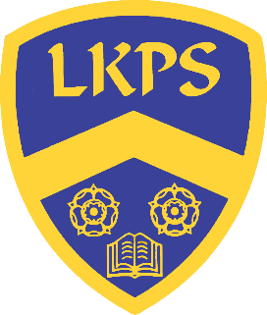
Spring

 | W1 | W2 | W3 |  | W4 | W5 | W6 |  | W1 | W2 | W3 | W4 | W5 | W6
Science

Non-Core | Geography: What makes a capital city and why is London our capital city? |  |  | Art: Life in Colour(Painting and Mixed Media) |  | Science: What is a habitat and how are they different?  (Living things and their habitats) |  |  | History: Who were the Victorians and what did they change? |  | Art: Clay houses (Sculpture) |  | DT: Fairground Wheels (Mechanisms)
Computing | Programming 1  Algorithms and debugging  OS Safety Lesson 3 |  |  |  |  |  |  |  | Programming 2  Scratch Jr  OS Safety Lesson 4
RE | How and why do we celebrate special and sacred times?  Christianity and Islam  Expressing |  |  |  |  |  |  |  | Cont…How and why do we celebrate special and sacred times?  Christianity and Islam  Expressing
Music | I Wanna Play In A Band |  |  |  |  |  |  |  | Zootime
PE | Fundamental Movement Skills 3 |  |  |  |  |  |  |  | Target Games 3
PSHE | Health and wellbeing  Safety and the changing body |  |  |  |  |  |  |  | Safety and the changing body  Citizenship
Spanish | Not taught in KS1 |  |  |  |  |  |  |  | Not taught in KS1

Summer

 | W1 | W2 | W3 | W4 | W5 |  | W1 | W2 | W3 | W4 | W5 | W6 | W7
Science | How do plants grow?  (Plants) |  |  |  |  |  | How do properties of materials affect what they are used for?  (Materials)
Non-Core |  |  | Geography: How are London and Chembakolli similar & different? |  |  |  |  |  | History: How did some significant people impact the world? |  |  | DT: Make a moving monster (Mechanisms)
Computing | Computing systems and networks 2  Word processing  OS Safety Lesson 5 |  |  |  |  |  | Data handling  International Space Station
RE | How should we care for others and the world, and why does it matter?  Christianity and Judaism  Living |  |  |  |  |  | Continued… How should we care for others and the world, and why does it matter?  Christianity and Judaism  Living
Music | Friendship Song |  |  |  |  |  | Reflect, Rewind and Replay
PE | Invasion Game Skill 2 |  |  |  |  |  | Striking and Field Games 2
PSHE | Citizenship |  |  |  |  |  | Economic wellbeing  Transition lesson
Spanish | Not taught in KS1 |  |  |  |  |  | - Greetings  - Numbers 1-10 & Colours

